**Create Defect during Test Execution and Linking Test case to an existing Defect.**

Option1: During execution creating a defect and TCER will be automatically linked to the Defect.

Go to Test Case Execution Records

How to view the Current status of TCER – look for the Last Result

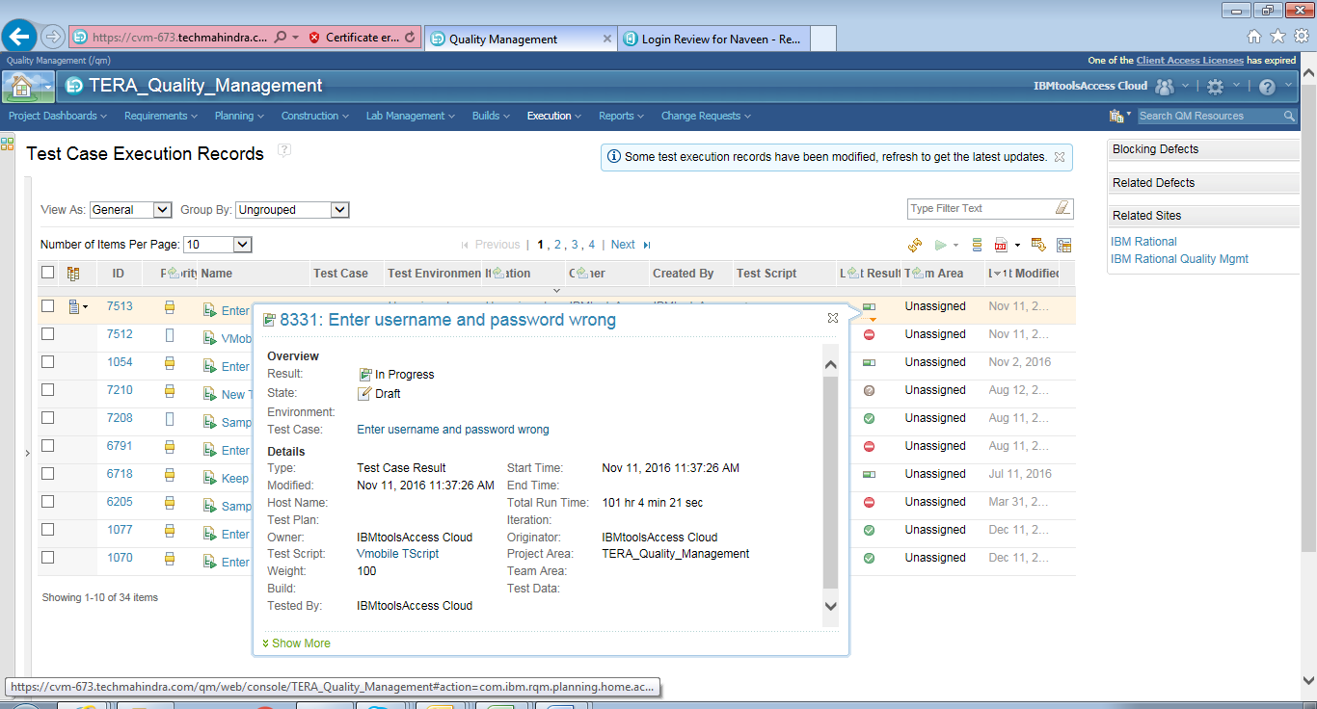

Select a TCER and Run Test – Run/Resume Execution/Run with Options..etc

Here Consider TCER ID as 7513

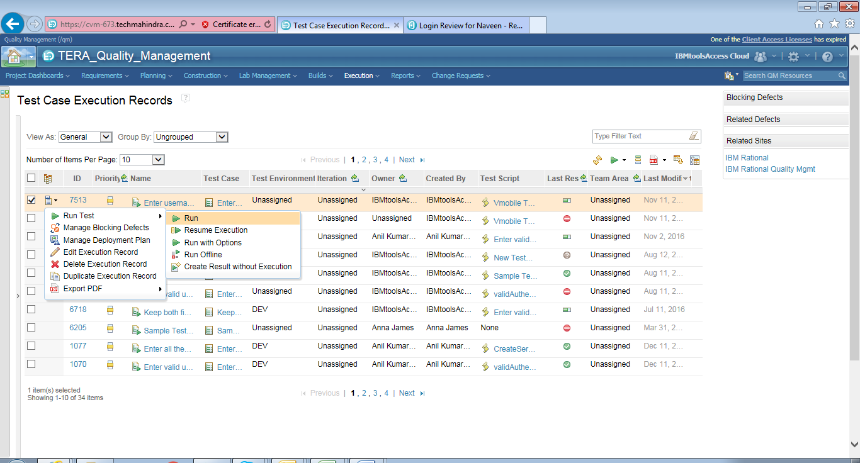

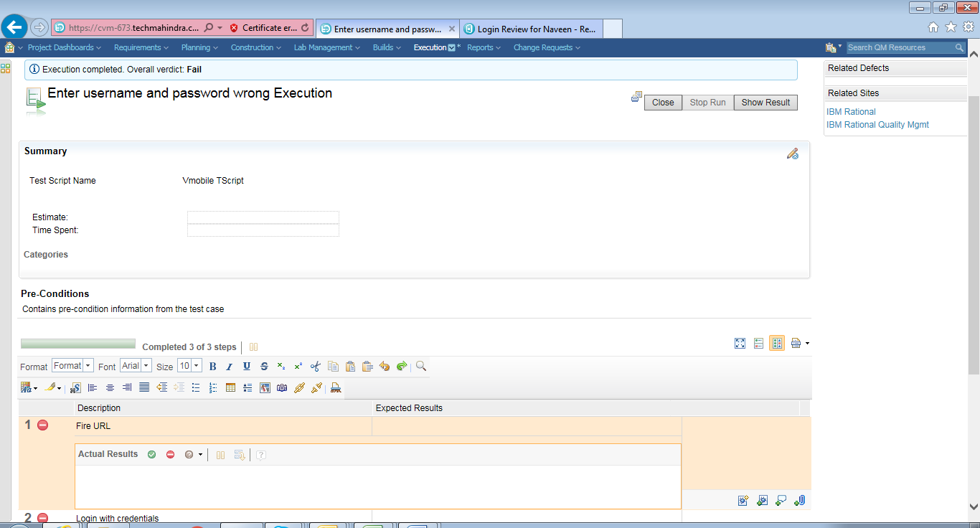

On Right Side of you will find an option to Create a Defect.

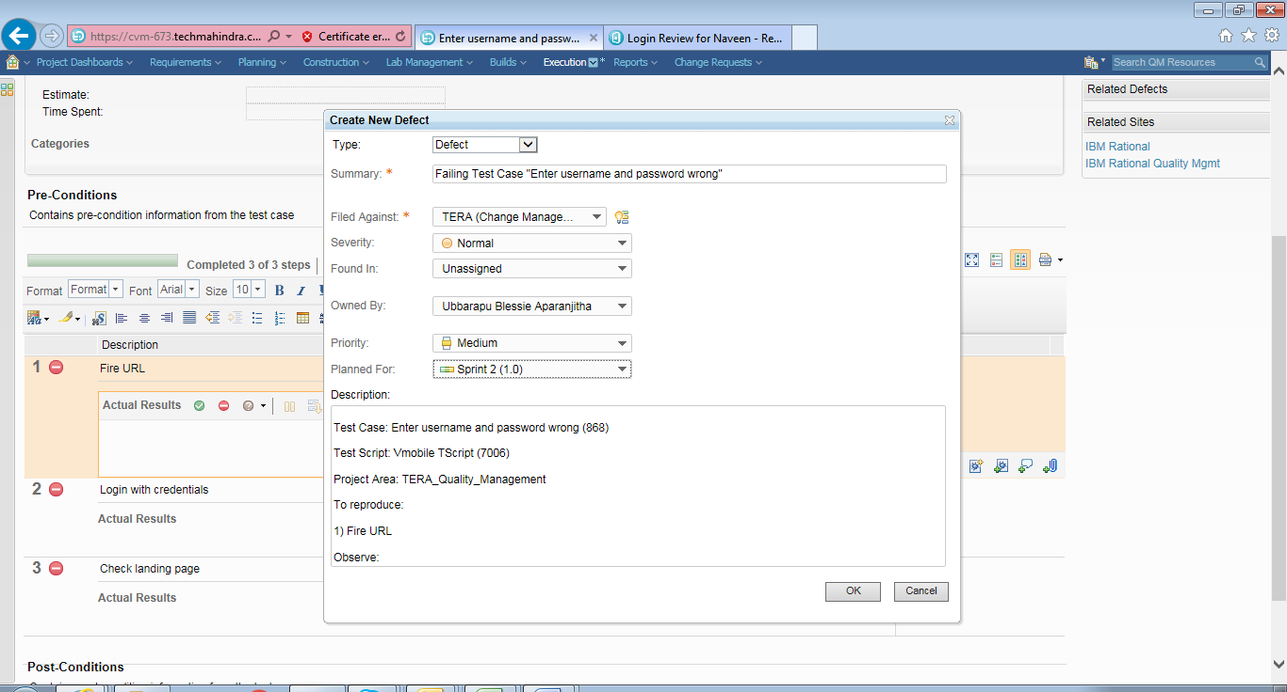

The Moment you clicked on OK – Defect is Created and Linked with the Test Case.

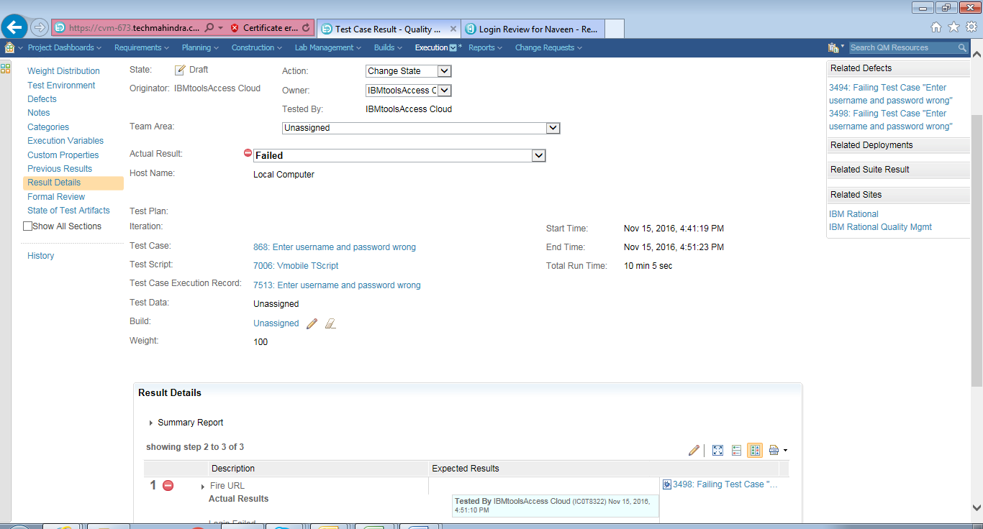

Click on the Defect: Here the Defect ID is 3498

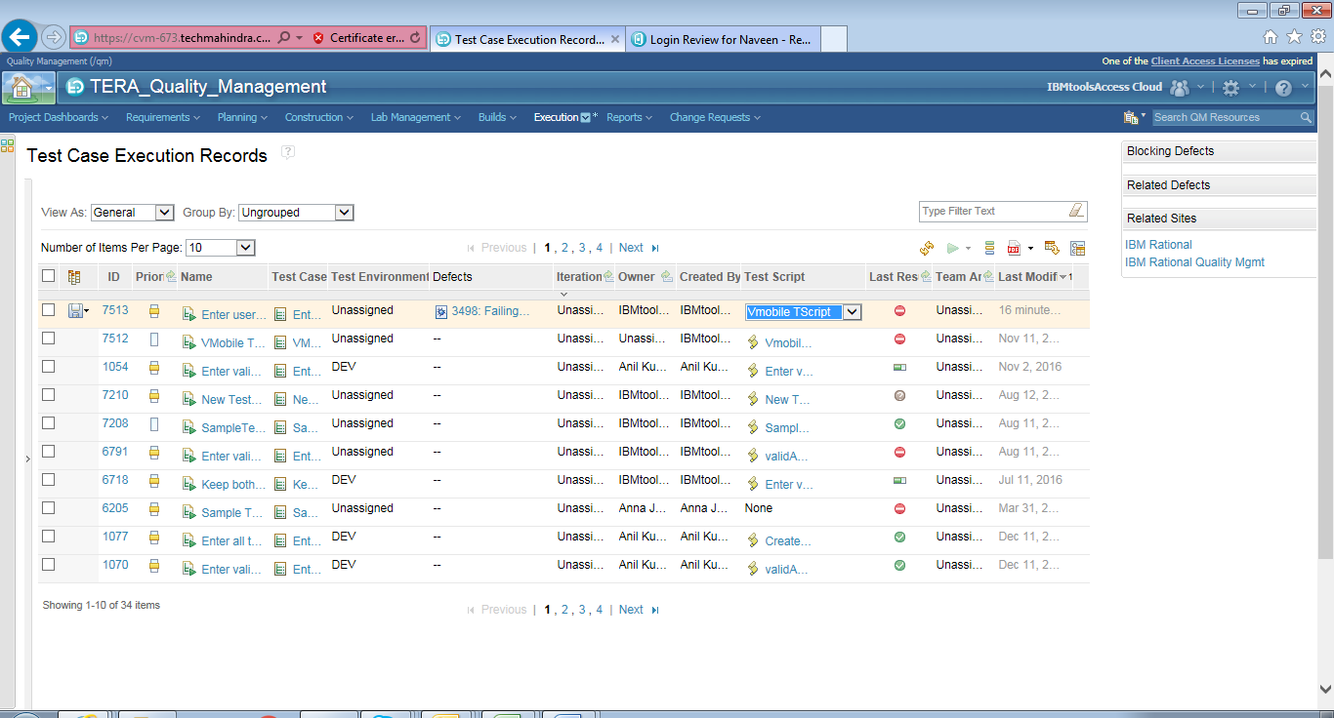

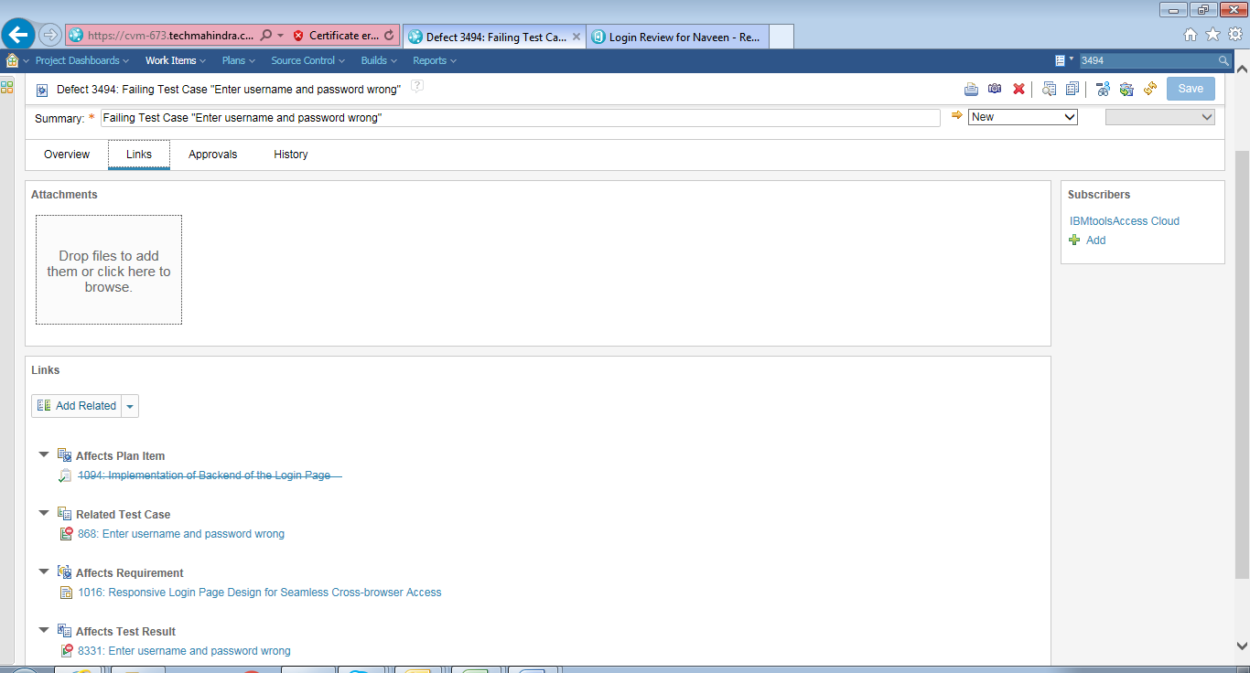

Option2:A defect in place and under Links “Add – related” you can link a Test case/ Requirement/Work Item.

<https://cvm-673.techmahindra.com/ccm/>

project: JKE_Banking1 (Change Management)

